Vocational Training Report
On
West Bound Ramp of MAA- Flyover
Under
Kolkata Metropolitan Development Authority (KMDA).
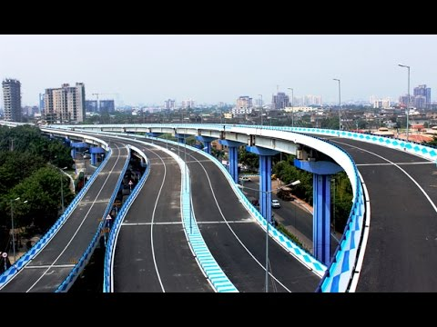
Submitted by: -
Abhishek Das.
Roll No. 33201315002.
Techno India Batanagar.
INDEX

SERIAL NO. DESCRIPTION
- 1 Preface

- 2 Project overview

- 3 Safety engineering

- 4 Pier and pier cap
Erection

- 5 Pier and pier-cap
Joining

- 6 Deck-slab

- 7 Acknowledgement

- 8 Conclusion

PREFACE
Kolkata is the capital of the Indian state of West Bengal. Located at the east bank of river Hooghly ,it is the principal commercial ,cultural ,educational centre of East India ,while the port of Kolkata itself is the oldest operational port and its sole major river in port .According to survey conducted by International Association of Public Transport ,Kolkata rank among the top six cities surveyed in India in terms of public transport system .
Apart from all this various types of transport facilities, there exists a very huge transport constrain in most part of the city.
The construction of flyover is one of the way to solve the traffic problem by diverting the vehicle to the third dimensions when the existing both dimensions have no space left because of heavy traffic.
It has been very invaluable experience, thereby helping us a lot in understanding a construction procedure of bridge and understanding the project management of huge project with safety precautions.

KMDA –Kolkata Metropolitan Development Authority : KMDA is a statutory authority functioning under the administrative control of Urban Development Department of Government of West Bengal. KMDA was established in 1970 under presidential ordinance and later sanctified under KMDA act, 1972 as a development agency. With the evolution of functions of KMDA over 35 yrs., KMDA has become an epitome for urban planning and development in KMA. KMDA role is a multi-disciplinary agency of city planning and sculpts new area and township. KMDA is also a technical secretariat to Kolkata metropolitan planning committee. Currently KMDA has been engaged in implementation planning committee. 1) Calcutta megacity programme 2) Basic minimum services 3) Gap, phase 2

SAFETY ENGINEERING

Safety aspect of the project:
If the working environment around you is clean, then automatically it brings confidence in you to work, and give best outputs. HCC gives lots of importance to safety aspect in engineers & workmen. The main aim of safety is zero accident.
• Strives to achieve zero accident rates through having an effective and competent site management team and trained workforce.
• In case of emergencies. the project management team is always ready and quick to respond to them.
The uses of protective gears like safety helmets. Protective shoes. Safety nets etc. are strictly enforced among the workers at the site.
List of job specific PPE.
All personnel shall be provided with proper. Personal Protective. Equipment (PPE)'s at site premises. Safety helmets. Safety shoes and other PPE's suitable for nature of work shall wear at all times by all the engineers, supervisors, surveyors, labours, trainees at the project Site. ln this project Hindustan construction company limited has provided specific PPE which are listed below:
1. Safety helmet.
2. Safety shoes.
3. Rubber hand gloves.
4. Goggles.
5. Hand Gloves.
6. Face Shield (Attached to welding helmet).
7. Safety Belt.
8. Dust Mask.
9. Gumboot.
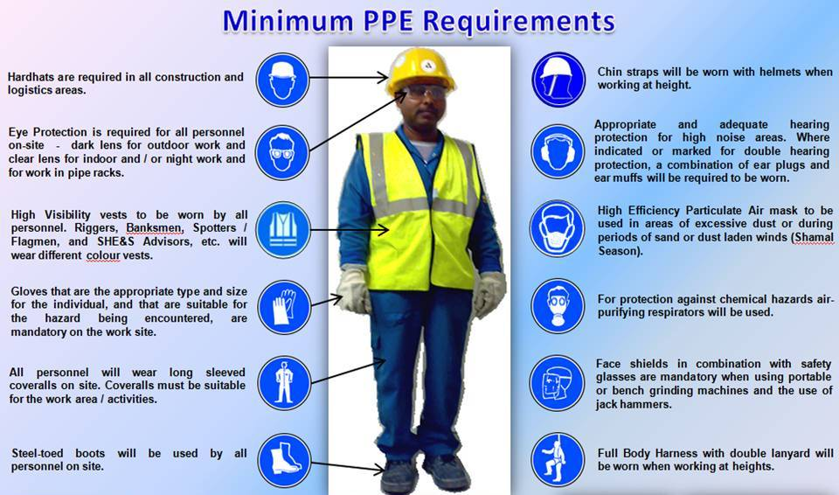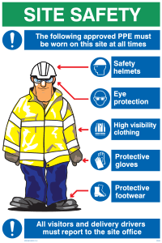

PIER AND PIER CAP
The geographical and topographical characteristics of a bridge location influences the method used for erection of steel structures. The Principle Method of erections are:
- Erection by crane,
- Cantilever erection,

- PIER ERECTION :

In the process of erection of segments, the symmetry is maintained. After the pier segments has been placed on the pier, field segments will be placed pair by pair on both sides of the pier segment in order to create a balanced cantilever.
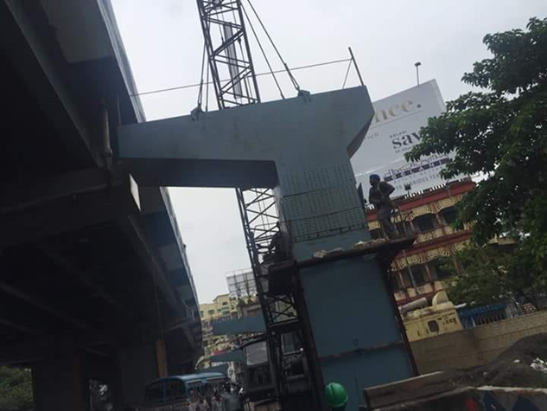

- PIER-CAP ERECTION :

During this erection process, the pier segment will be temporarily supported by hydraulic jacks. In this way, the unbalanced moment imposed on the pier can be maintained. In this way, the unbalanced moment imposed on the pier can be minimised and stability can be maintained.

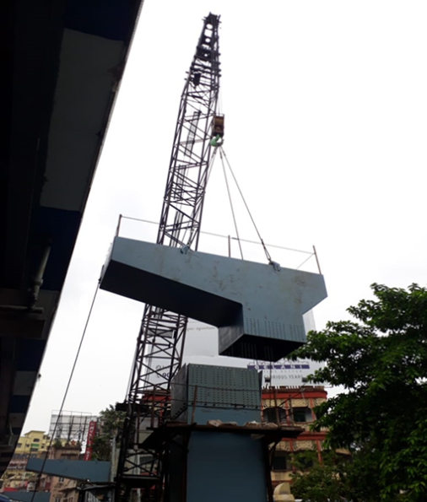

PIER AND PIER CAP JOINING (BOLTING):-

BOLT JOINT: -
Bolted joints are one of the most common elements in construction and machine design. They consist of fasteners that capture and join other parts, and are secured with the mating of screw threads. Typically, a bolt is tensioned (preloaded) by the application of a torque to either the bolt head or the nut. The applied torque causes the bolt to climb the thread causing a tensioning of the bolt and an equivalent compression in the components being fastened by the bolt.
SPECIFICATION OF BOLT JOINT (PIER-PIER CAP): -
BOLT DIAMETER: - 22m.
NO. OF BOLTS USED: - 896 PER PIER.
TIGHTENING TORQUE: - 590 N-mm.
SPECIFICATION OF BOLT JOINT (PIER-PIER CAP):-
BOLT DIAMETER: - 70mm.
NO. OF BOLTS USED: - 72 PER PIER.

PIER AND PIER CAP JOINING

(WELDING):-

WELDING: -
It is a fabrication or sculptural process that joins materials, usually metals or thermoplastics, by causing fusion, which is distinct from lower temperature metal joining techniques such as brazing and soldering, which do not melt the base metal.
SPECIFICATION OF WELDING: -
WELDING ROD: - ESAB OK 73.08 E 8018-G
WELD LENGTH: - 12 mm.
WELD TYPE: - FILLET WELD.

DECK SLAB

Deck, is the surface of a bridge, and is one structural element of the superstructure of a bridge. It is not to be confused with any deck of a ship. The deck may be constructed of concrete, steel, open grating, or wood. Sometimes the deck is covered with asphalt concrete or other pavement. The concrete deck may be an integral part of the bridge structure or it may be supported with I-beams or steel girders.

The Superstructure consists of the following components:

- Deck slab.

- Cantilever slab portion.

- Footpaths, if provided, kerb and handrails or crash barriers.

- Longitudinal girders, considered in design to be of T-section.

- Cross beams or diaphragms, intermediate and end ones.

- Wearing coat

STEEL FORMWORK Construction

Formworks: Forms are molds to receive concrete in its’ plastic form. Formwork is temporary structure, as such, it is not normally shown on the drawings. Formwork for Beams and Slabs

Definition: Its is an artificial support provided below and around the precast or cast in situ concrete work. Formwork is commonly made of Steel, wood• Formwork construction & casting is of prime importance in concrete industry. It share a significant amount of concrete cost.

Qualities of formwork- It should be water tight, It should be strong, It can be reusable, Its contact surface should be uniform, It should be according to the size of member.

Types of formwork- Formwork are mainly of two types they are: Steel formwork and Wooden formwork.

• Steel formwork is made of Steel sheets, Angle Iron, Tee Iron

• Wooden formwork consists of Props, Planks battens, Ledgers, sheeting.

- Temporary Structure- Temporary structure required to safely support concrete until it reaches adequate strength.

• Permanent Structure- Permanent formwork remains in situ for the life of the building

Steel Formwork-This consist of panels fabricated out of thin steel plates stiffened along the edges by small steel angles.
• The panel units can be held together through the use of suitable clamps or bolts and nuts.

• The panels can be fabricated in large number in any desired modular shape or size.

• Steel forms are largely used in large projects or in situation where large number reuses of the shuttering is possible.

• This type of shuttering is considered most suitable for circular or curved structures.
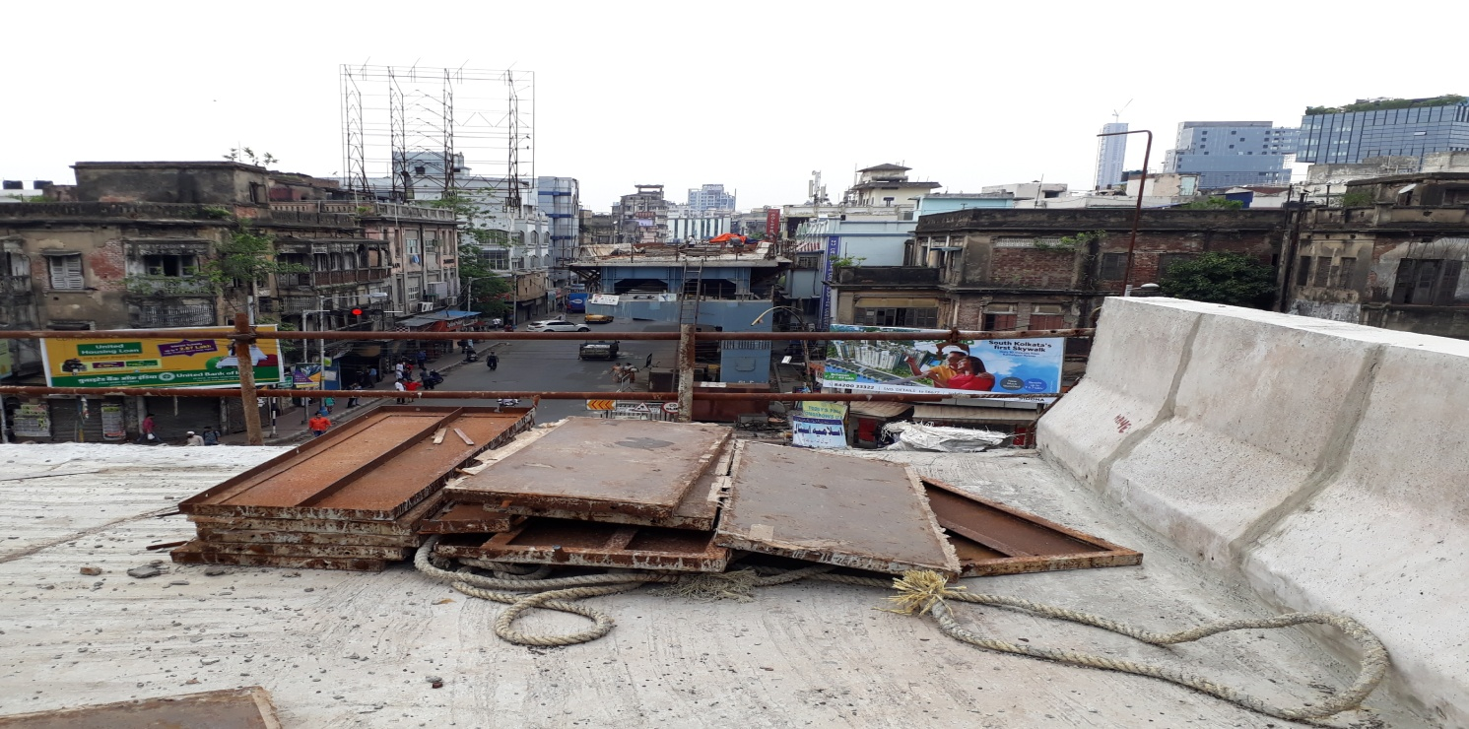 Steel shuttering plates

Rebar: Reinforcing Steel Bar
Reinforcing bars are hot-rolled using different steel materials. Most rebar’s are rolled from new steel billets, but others are rolled from steel debris or railroad rails. Rebar’s are required to contain some sort of identification that can be used to identify the mill that produced the reinforcing steel bar

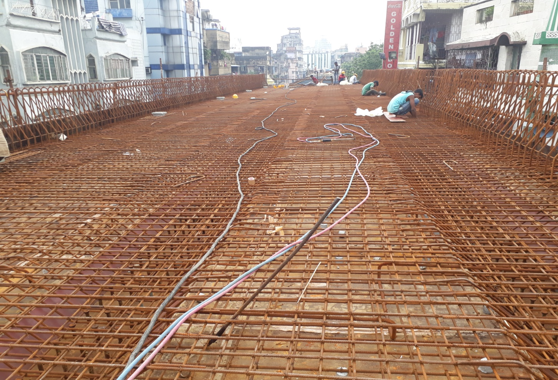

Binding of reinforcement

Expansion joints:
Bridge expansion joints are designed to allow for continuous traffic between structures while accommodating movement, shrinkage, and temperature variations on reinforced and prestressed concrete, composite, and steel structures. They stop the bridge from bending out of place in extreme conditions, and also allow enough vertical movement to permit bearing replacement ^{[1]} without the need to dismantle the bridge expansion joint. There are various types, which can accommodate movement from 30 to 1,000 millimeters (1.2 to 39.4 in). They include joints for small movement (EMSEAL BEJS, XJS, JEP, WR, WOSd, and Granor AC-AR), medium movement (ETIC EJ, Wd), and large movement (WP, ETIC EJF/Granor SFEJ).

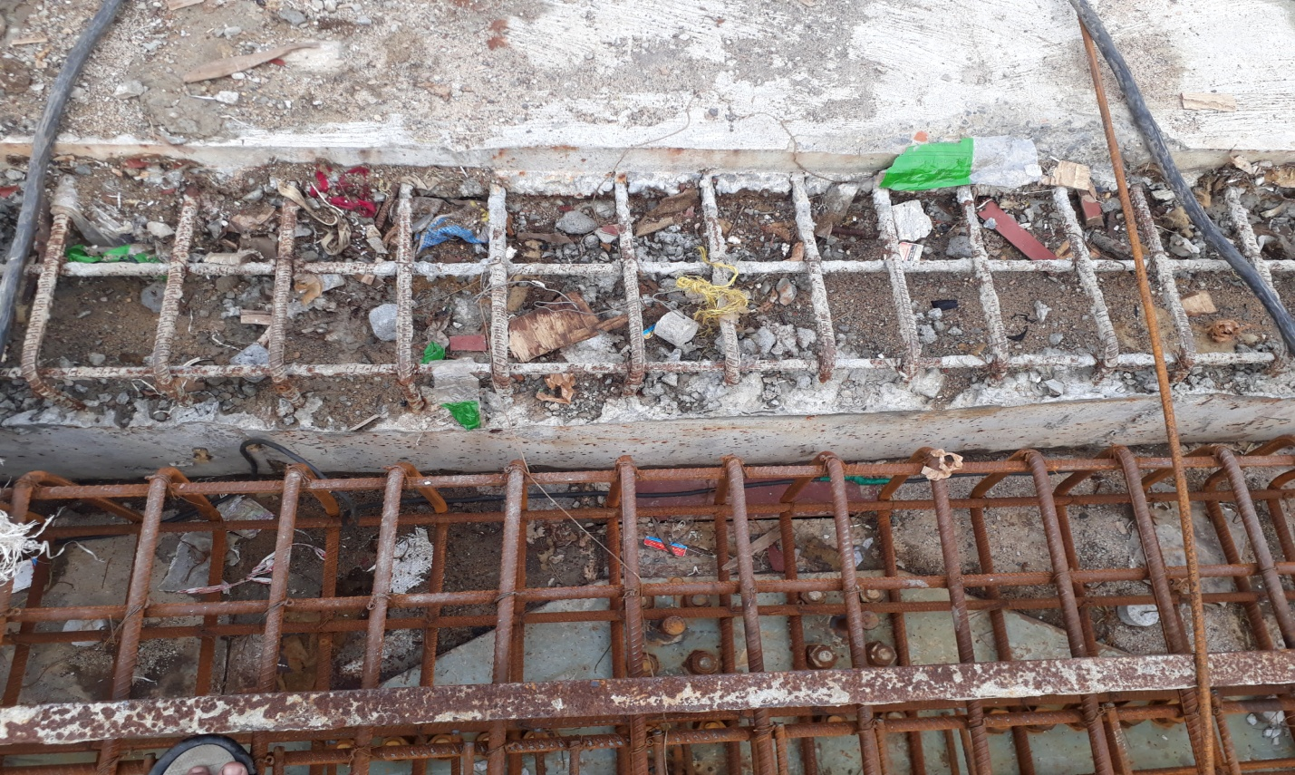

ACKNOWLEDGEMENT:
I would like to express my deepest appreciation to all those who provided me the possibility to complete this Industrial Training. A special gratitude I give to our respected Head of the Department of Civil Engineering of Techno India Batanagar, Mr. Jayanta Maity, whose contribution in stimulating suggestions and encouragement, helped me to coordinate my project especially in writing this report.
Furthermore, I would also like to acknowledge with much appreciation the crucial roles of the Chief Engineer of KMDA (R & B Sector) Shri Debashis Manna, the Executive Engineer of KMDA (R & B Sector) Shri Utpal Ranjan Dey, the Project Manager of HCC, the on-site engineers of HCC, & the safety engineer of HCC.
I would also like to express my gratitude to our respected Principal Mr. Ankur Ganguly, and our respected Director Mr. R.N Lahiri.

CONCLUSION:

In the end, I could not express in words the amount of experience I gained from the on-site vocational Industrial training on the Maa Flyover Project. I sincerely hope to practically apply the vast knowledge I gained in this training in the professional life in the near future .

THANK-YOU

